ASSIGNMENT NO # 03



Design Patterns

Group Members:

Ahmed Ali 19p-0042

Fehmid E Bin Jamil 19p-0014

Chain of Command Design Pattern:

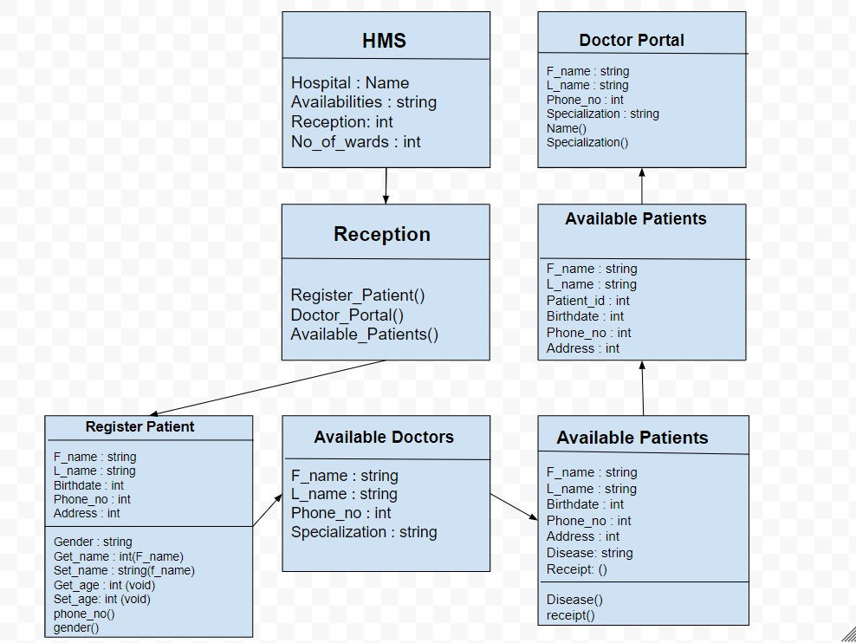

State Design Pattern:

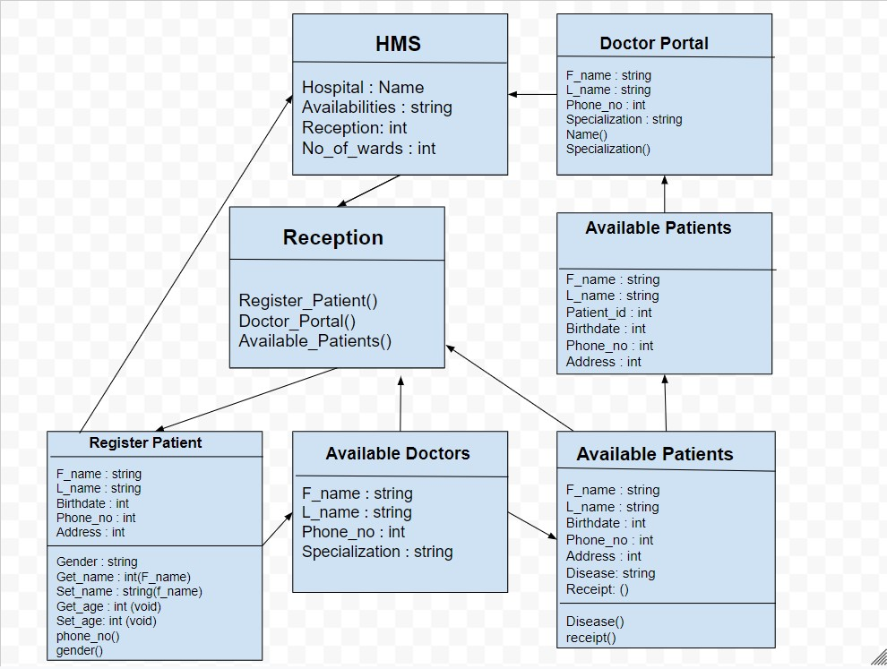

Strategy Design pattern:

